**Fundamental data type sizes**

The obvious next question is “how much memory do variables of different data types take?”. You may be surprised to find that the size of a given data type is dependent on the compiler and/or the computer architecture!

C++ only guarantees that each fundamental data types will have a minimum size:

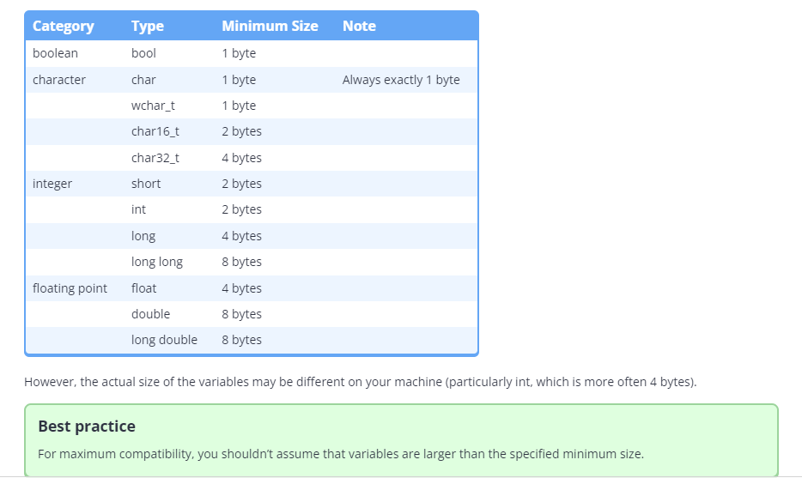

**Fundamental data type performance**

On modern machines, objects of the fundamental data types are fast, so performance while using these types should generally not be a concern.

**As an aside…**

You might assume that types that use less memory would be faster than types that use more memory. This is not always true. CPUs are often optimized to process data of a certain size (e.g. 32 bits), and types that match that size may be processed quicker. On such a machine, a 32-bit int could be faster than a 16-bit short or an 8-bit char.

